**BAI3270 PeopleTools Assignment 3**

Name: ______________________

PeopleSoft Account: _NAIT___________________

***Use: HCM 9.0 – NAIT 1->Enterprise Learning ->Result Tracking->Manage Person Profile->Evaluate Course Session***

1. What is the page name __________________

What is the Component name? _____________________________________

What record is the field Course from? ________________________________

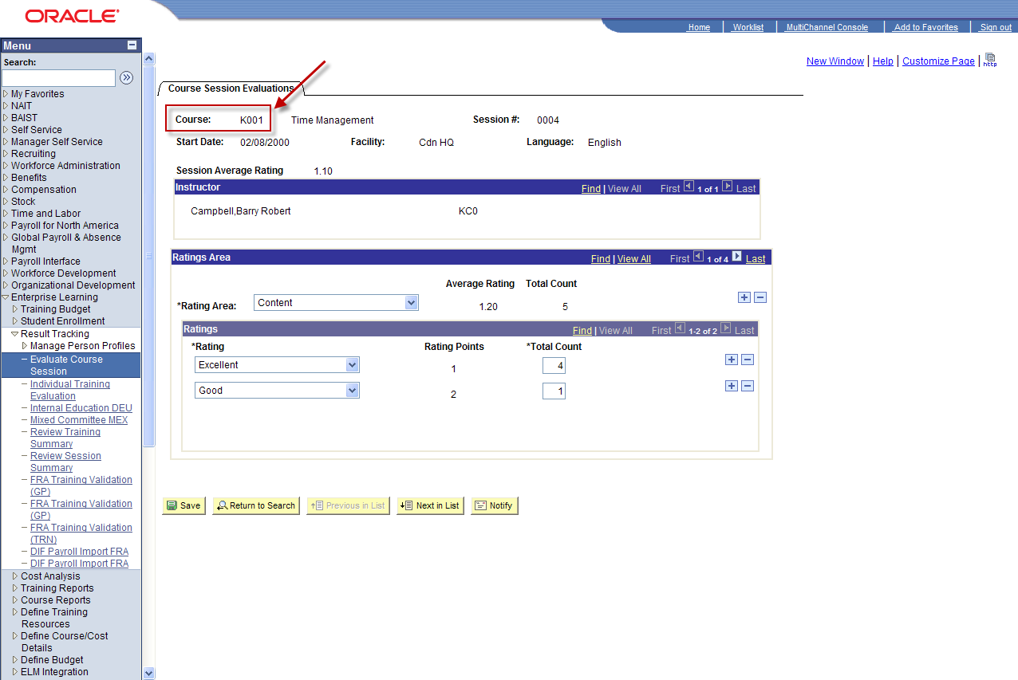

***Use: HCM 9.0 – NAIT 1->Enterprise Learning -> Student Enrollment-> Enroll by Department Demands***

2. What is the name of this page? ___________________________________

What is the Component name? _____________________________________

How many Pages are in the Component? _____________________________

What record is Demand ID from? ____________________________________

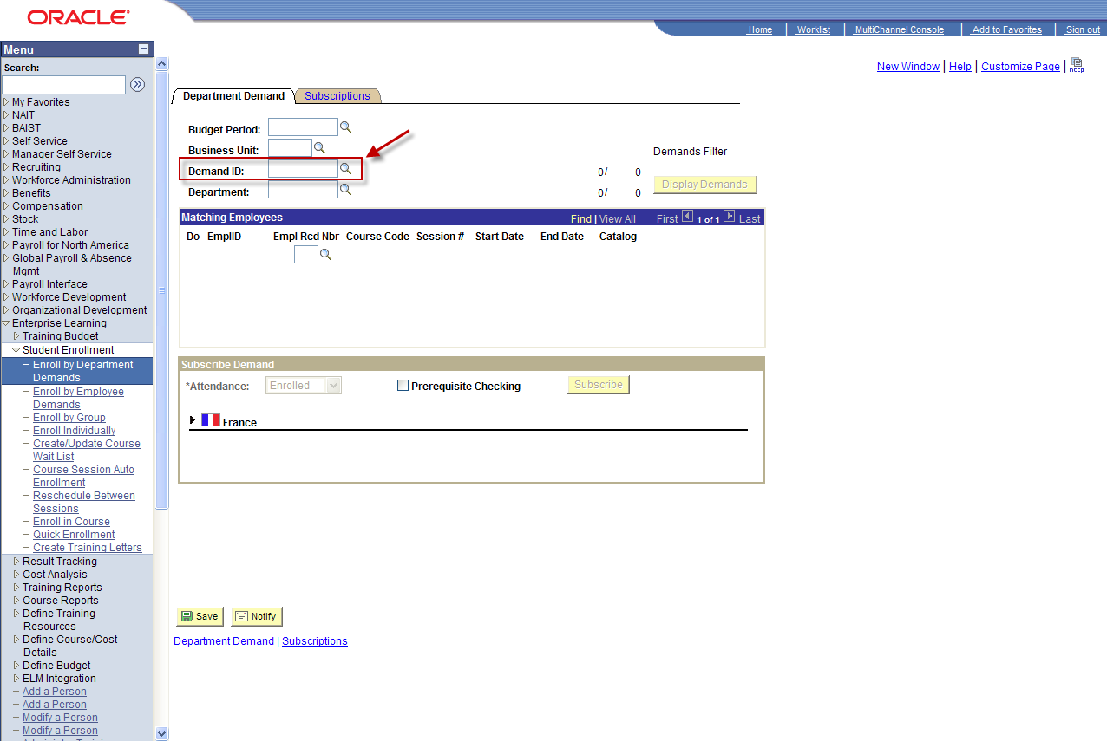

***Use: HCM 9.0 – NAIT 1->Recruiting -> Find Job Openings***

3. What is the Record Name for the Group Box? _________________________

What is the Field Name for the Group Box? _____________________________

